- Write a program to create bar plot for sample data using matplotlib.

import matplotlib.pyplot as plt

categories = ['Product A', 'Product B', 'Product C', 'Product D', 'Product E']
sales = [350, 480, 290, 610, 420]

plt.figure(figsize=(9, 6))

bars = plt.bar(categories, sales, color='#3498db', edgecolor='navy', alpha=0.85, width=0.6)

plt.title('Product Sales Performance', fontsize=16, fontweight='bold', pad=15)
plt.xlabel('Products', fontsize=12, labelpad=10)
plt.ylabel('Units Sold', fontsize=12, labelpad=10)

plt.grid(axis='y', linestyle='--', alpha=0.7)

for bar in bars:
yval = bar.get_height()
plt.text(bar.get_x() + bar.get_width()/2.0, yval + 10, f'{yval}', ha='center', va='bottom', fontsize=10)

plt.tight_layout() # Ensures everything fits perfectly without clipping
plt.show()

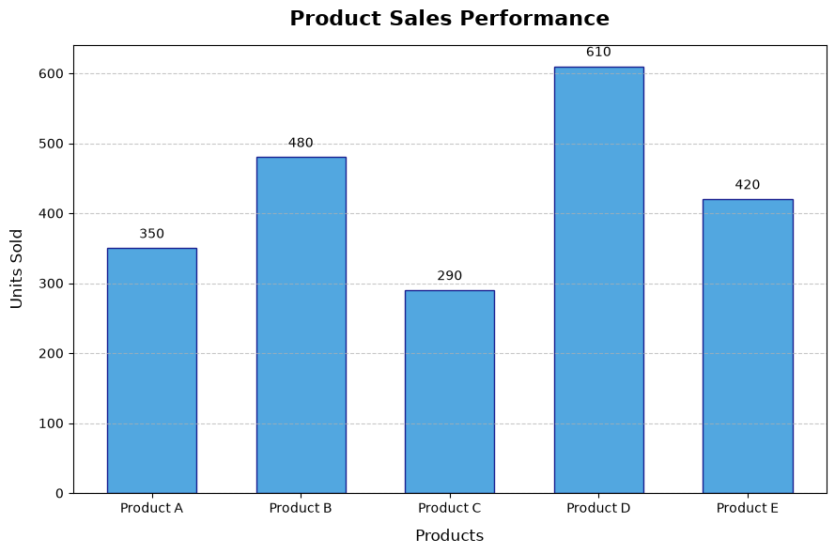

- Write a program to create stacked-bar plot for sample data using
matplotlib.

import matplotlib.pyplot as plt
import numpy as np

quarters = ['Q2', 'Q1', 'Q3', 'Q4'] # Sorted by total sales
prod_a = [35, 20, 30, 35]
prod_b = [32, 25, 34, 20]
prod_c = [20, 45, 26, 41]

prod_a = np.array(prod_a)
prod_b = np.array(prod_b)
prod_c = np.array(prod_c)

fig, ax = plt.subplots(figsize=(9, 6))

bars1 = ax.bar(quarters, prod_a, label='Product A', color='#2ecc71', width=0.5)
bars2 = ax.bar(quarters, prod_b, bottom=prod_a, label='Product B', color='#3498db', width=0.5)
bars3 = ax.bar(quarters, prod_c, bottom=prod_a+prod_b, label='Product C', color='#e74c3c', width=0.5)

ax.set_title('Quarterly Sales Breakdown by Product', fontsize=16, fontweight='bold', pad=15)
ax.set_xlabel('Quarters', fontsize=12, labelpad=10)
ax.set_ylabel('Units Sold', fontsize=12, labelpad=10)
ax.grid(axis='y', linestyle='--', alpha=0.5)
ax.legend(loc='upper left')

for i in range(len(quarters)):
ax.text(i, prod_a[i]/2, str(prod_a[i]), ha='center', va='center', color='white', fontweight='bold')
ax.text(i, prod_a[i] + prod_b[i]/2, str(prod_b[i]), ha='center', va='center', color='white', fontweight='bold')
ax.text(i, prod_a[i] + prod_b[i] + prod_c[i]/2, str(prod_c[i]), ha='center', va='center', color='white', fontweight='bold')
total = prod_a[i] + prod_b[i] + prod_c[i]
ax.text(i, total + 2, str(total), ha='center', va='bottom', fontweight='bold')

plt.tight_layout()
plt.savefig('stacked_bar_plot.png', dpi=300)
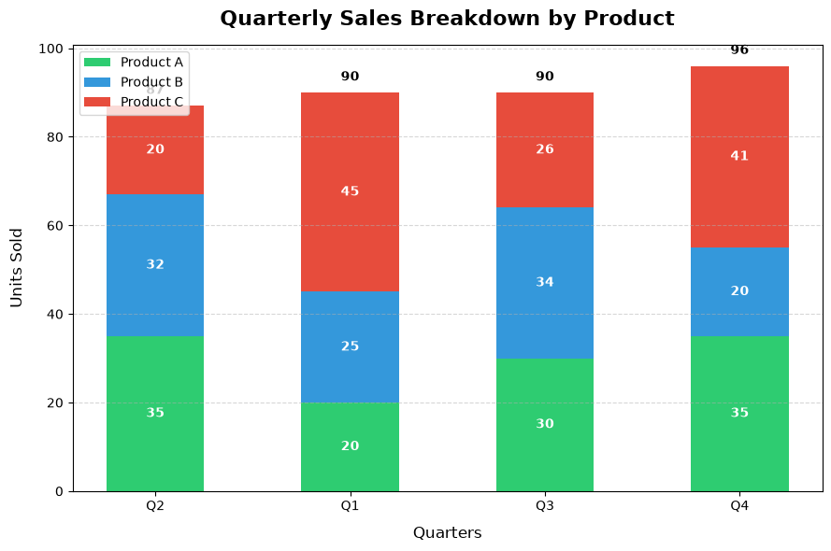

- Write a program to create pie plot for sample data using matplotlib.

import matplotlib.pyplot as plt

market_share = [35, 25, 20, 15, 5]
labels = ['Company A', 'Company B', 'Company C', 'Company D', 'Others']
colors = ['#ff9999','#66b3ff','#99ff99','#ffcc99','#c2c2f0']
explode = (0.05, 0, 0, 0, 0) # explode 1st slice

fig, ax = plt.subplots(figsize=(8, 8))
ax.pie(market_share, explode=explode, labels=labels, colors=colors,
autopct='%1.1f%%', shadow=True, startangle=140,
textprops={'fontsize': 12})

ax.set_title('Market Share Distribution', fontsize=16, fontweight='bold', pad=20)
plt.tight_layout()
plt.savefig('pie_chart.png', dpi=300)

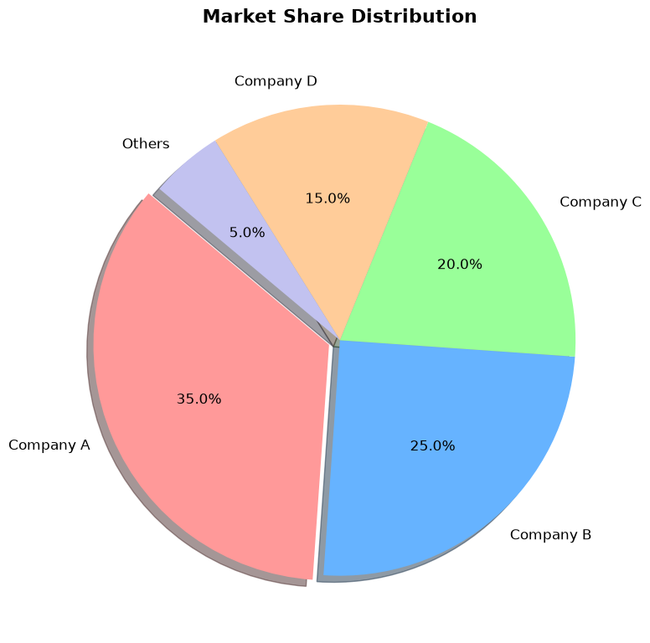

- Write a program to create pie plot using explode parameter for sample
data using matplotlib.

import matplotlib.pyplot as plt
categories = ['Housing', 'Food', 'Transportation', 'Entertainment', 'Utilities', 'Savings']
budget_shares = [30, 20, 15, 10, 15, 10]
explode = (0, 0.1, 0, 0, 0, 0.18)
colors = ['#34495e', '#e67e22', '#7f8c8d', '#9b59b6', '#95a5a6', '#2ecc71']
fig, ax = plt.subplots(figsize=(8, 8))
wedges, texts, autotexts = ax.pie(
budget_shares,
explode=explode,
labels=categories,
colors=colors,
autopct='%1.1f%%',
startangle=140,
shadow=True,
textprops=dict(color="black", fontsize=12)
)
for autotext in autotexts:
autotext.set_fontsize(11)
autotext.set_weight('bold')

ax.set_title('Monthly Expense & Savings Budget', fontsize=16, fontweight='bold', pad=20)
plt.tight_layout()

plt.savefig('exploded_pie_chart.png', dpi=300)
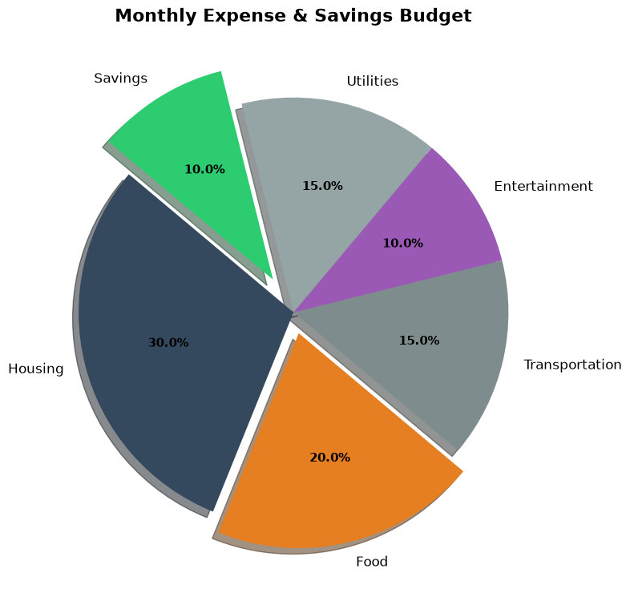

- Write a program to create scatter plot for sample data using matplotlib.

import matplotlib.pyplot as plt

adv_spend = [12, 18, 25, 32, 38, 45, 52, 61, 68, 75, 82, 90]
sales_revenue = [15, 28, 22, 41, 35, 50, 65, 58, 78, 85, 74, 95]
audience_size = [50, 80, 60, 120, 90, 150, 200, 110, 250, 300, 180, 400]
fig, ax = plt.subplots(figsize=(9, 6))
scatter = ax.scatter(
adv_spend,
sales_revenue,
s=audience_size,
color='#9b59b6',
edgecolor='#6c3483',
alpha=0.75,
marker='o'
)
ax.set_title('Impact of Advertising Spend on Sales', fontsize=16, fontweight='bold', pad=15)
ax.set_xlabel('Advertising Budget ($, Thousands)', fontsize=12, labelpad=10)
ax.set_ylabel('Sales Revenue ($, Thousands)', fontsize=12, labelpad=10)

ax.grid(True, linestyle='--', alpha=0.5)
plt.tight_layout()
plt.show()

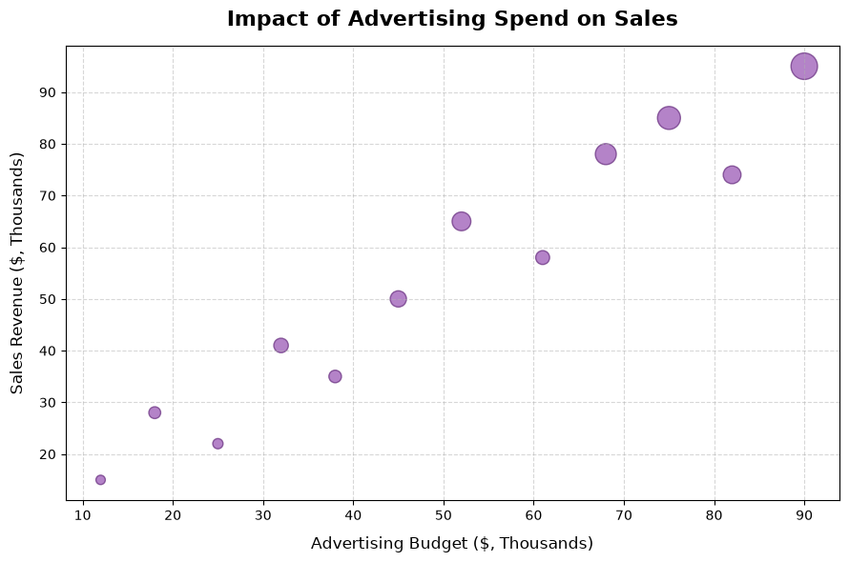

6) Write a program to create line plot for sample data using matplotlib.

import matplotlib.pyplot as plt

months = ['Jan', 'Feb', 'Mar', 'Apr', 'May', 'Jun']
profit = [12.5, 14.2, 13.8, 16.5, 19.1, 21.4] # in thousands

fig, ax = plt.subplots(figsize=(9, 5))

ax.plot(
months,
profit,
color='#1abc9c',
linestyle='-',
linewidth=2.5,
marker='o',
markersize=8,
markerfacecolor='#16a085',
markeredgecolor='white',
markeredgewidth=1.5
)
ax.set_title('Monthly Profit Progression (H1)', fontsize=16, fontweight='bold', pad=15)
ax.set_xlabel('Months', fontsize=12, labelpad=10)
ax.set_ylabel('Profit ($, Thousands)', fontsize=12, labelpad=10)
ax.grid(True, linestyle=':', alpha=0.6)
plt.tight_layout()
plt.show()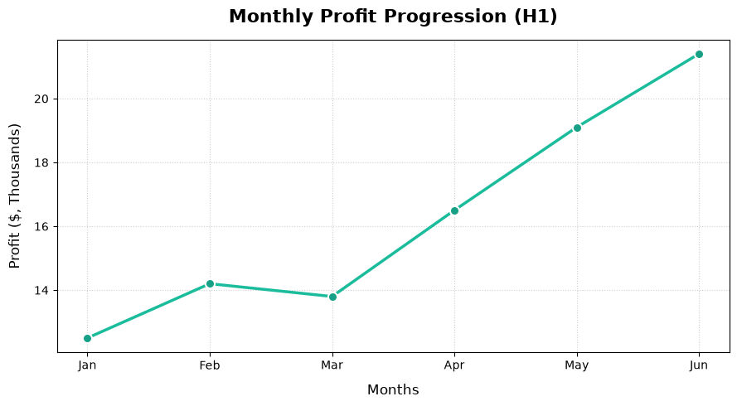
7) Write a program to create Multi-line plot for sample data using
matplotlib.

import matplotlib.pyplot as plt

months = ['Jan', 'Feb', 'Mar', 'Apr', 'May', 'Jun']
product_a_sales = [15.2, 17.4, 16.8, 22.1, 24.5, 27.3]
product_b_sales = [12.0, 11.5, 14.2, 13.8, 16.1, 15.4]
product_c_sales = [22.4, 21.8, 20.5, 19.2, 18.0, 16.5]

fig, ax = plt.subplots(figsize=(10, 6))
ax.plot(months, product_a_sales, label='Product A',
color='#1abc9c', linestyle='-', linewidth=2.5,
marker='o', markersize=7)

ax.plot(months, product_b_sales, label='Product B',
color='#e67e22', linestyle='--', linewidth=2.5,
marker='s', markersize=7)

ax.plot(months, product_c_sales, label='Product C',
color='#e74c3c', linestyle=':', linewidth=2.5,
marker='^', markersize=7)

ax.set_title('6-Month Sales Trend Comparison', fontsize=16, fontweight='bold', pad=15)
ax.set_xlabel('Months', fontsize=12, labelpad=10)
ax.set_ylabel('Revenue ($, Thousands)', fontsize=12, labelpad=10)
ax.grid(True, linestyle=':', alpha=0.6)
ax.legend(loc='upper left', fontsize=11, frameon=True, facecolor='white', edgecolor='none')
plt.tight_layout()
plt.show()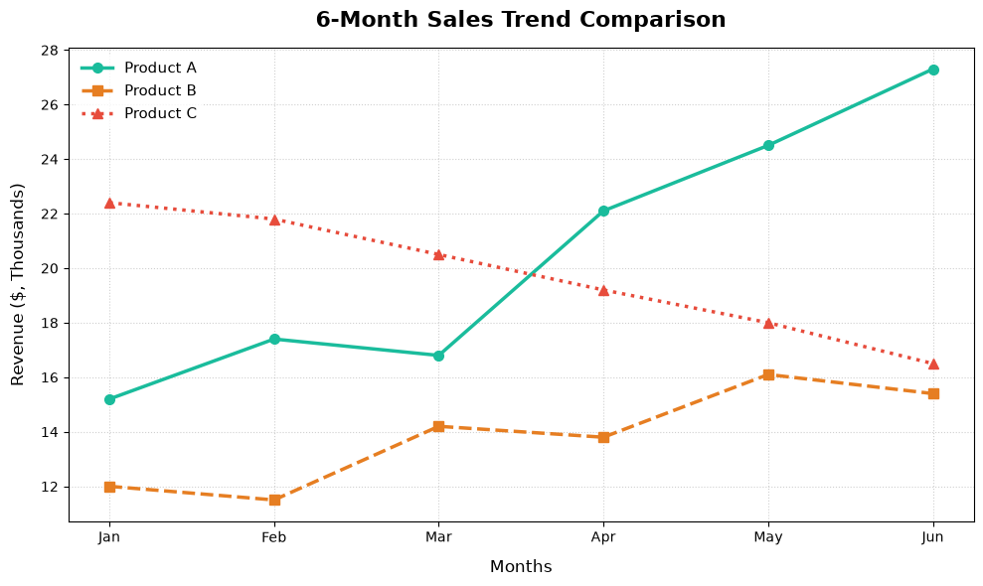

8) Write a program to create Histogram for sample data using matplotlib.

import matplotlib.pyplot as plt
import numpy as np

np.random.seed(42) # Setting a seed ensures the "random" data stays identical every run
exam_scores = np.random.normal(loc=75, scale=10, size=250)

fig, ax = plt.subplots(figsize=(9, 6))

n, bins, patches = ax.hist(
exam_scores,
bins=15,
color='#34495e', # Charcoal gray fill
edgecolor='white', # Crisp white borders between bins
alpha=0.85
)

ax.set_title('Distribution of Student Exam Scores', fontsize=16, fontweight='bold', pad=15)
ax.set_xlabel('Exam Scores (Percentage)', fontsize=12, labelpad=10)
ax.set_ylabel('Number of Students (Frequency)', fontsize=12, labelpad=10)
ax.grid(axis='y', linestyle='--', alpha=0.5)

plt.tight_layout()
plt.show()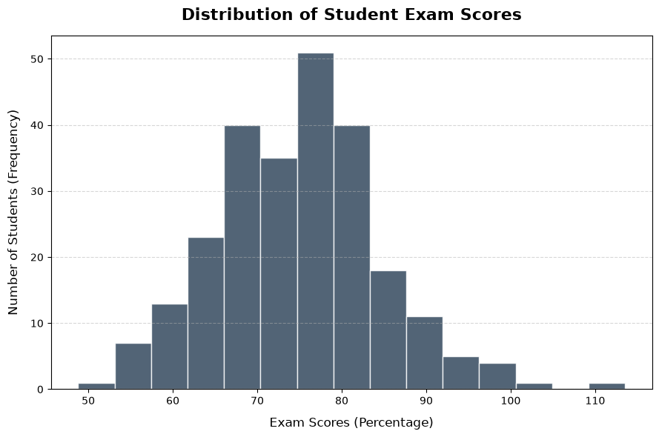
9) Write a program to create box plot for sample data using matplotlib.

import matplotlib.pyplot as plt
import numpy as np

np.random.seed(10)

class_a = np.random.normal(70, 10, 100)
class_b = np.random.normal(75, 12, 100)
class_c = np.random.normal(65, 8, 100)

data = [class_a, class_b, class_c]
labels = ['Class A', 'Class B', 'Class C']

fig, ax = plt.subplots(figsize=(9, 6))
box = ax.boxplot(
data,
patch_artist=True,
notch=False,
flierprops=dict(marker='o', markerfacecolor='#e74c3c', markersize=6, linestyle='none', markeredgecolor='none')
)
ax.set_xticks(range(1, len(labels) + 1))
ax.set_xticklabels(labels)

colors = ['#3498db', '#2ecc71', '#9b59b6']
for patch, color in zip(box['boxes'], colors):
patch.set_facecolor(color)
patch.set_alpha(0.7)
patch.set_edgecolor('#2c3e50')
patch.set_linewidth(1.5)

for whisker in box['whiskers']:
whisker.set(color='#2c3e50', linewidth=1.5, linestyle='--')

for cap in box['caps']:
cap.set(color='#2c3e50', linewidth=1.5)

for median in box['medians']:
median.set(color='#e74c3c', linewidth=2)

ax.set_title('Exam Score Distribution Across Classes', fontsize=16, fontweight='bold', pad=15)
ax.set_xlabel('Classes', fontsize=12, labelpad=10)
ax.set_ylabel('Scores', fontsize=12, labelpad=10)

ax.grid(axis='y', linestyle=':', alpha=0.6)

plt.tight_layout()
plt.savefig('box_plot.png', dpi=300)

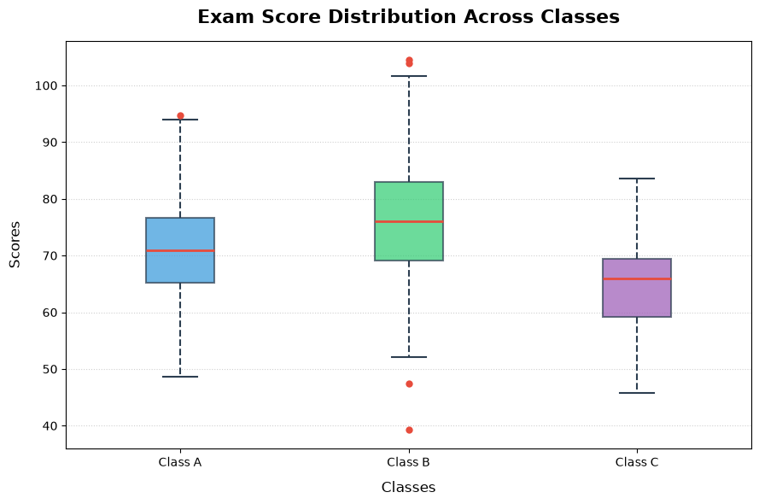

10 )Write a program to create 3D plot for sample data using matplotlib.

import matplotlib.pyplot as plt
import numpy as np

X = np.arange(-5, 5, 0.25)
Y = np.arange(-5, 5, 0.25)
X, Y = np.meshgrid(X, Y)
R = np.sqrt(X**2 + Y**2)
Z = np.sin(R)

fig, ax = plt.subplots(figsize=(10, 7), subplot_kw={"projection": "3d"})

surf = ax.plot_surface(X, Y, Z, cmap='viridis', edgecolor='none', alpha=0.9)

ax.set_title('3D Surface Plot', fontsize=16, fontweight='bold', pad=20)
ax.set_xlabel('X Axis', fontsize=12, labelpad=10)
ax.set_ylabel('Y Axis', fontsize=12, labelpad=10)
ax.set_zlabel('Z Axis', fontsize=12, labelpad=10)

fig.colorbar(surf, ax=ax, shrink=0.5, aspect=10, pad=0.1)

plt.tight_layout()
plt.savefig('3d_surface_plot.png', dpi=300)
